24 March ToDo Pre Order App

- Write on top: “Preorder by 5pm for next day delivery to your tazizi fridge” : “Not 6AM line” and make sure this line should be responsive/stays in one line.
- add feedback button with location (and send user to whatsapp and save the clicks along with location and timestamp) like the attached image (use whatsapp logo and write feedback with it), on click send user to whatsapp (+971 58 599 3723) with location and time
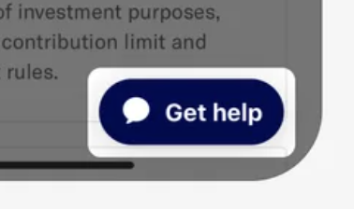
- On the payment page in total write “Discount” not “Weekly Discount”
- Rather than Delivery pickup (free) write “Delivery Location”: BD & Co. Fridge
- Write note on order confirmation screen to check spam as well for email confirmation
- In the email write somewhere follow us on instagram @tazizi.ae
- appbar is not updated properly, please check the old doc to make the appbar right/simple. Also, logo you used here have the lead purple idk from where you get this color logo, that should be green leaf.
- on stripe payment screen, after payment it stays there for 2-5 seconds without showing loading. Please fix something here as well maybe add loading if possible.
- In email title add the first word as Tazizi and remaining is fine
- Can we have the tazizi logo here in the Email from
- All Emails ending up in spam, what is the solution?
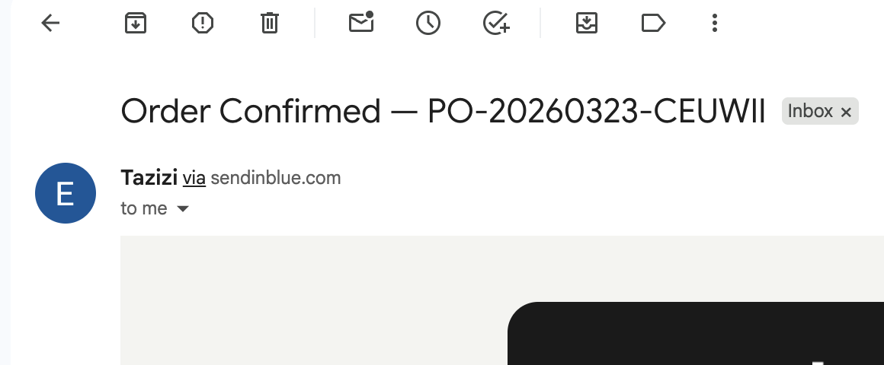

- The email is too much grey, please update colors to our branded colors. The full grey background could be white.
- Use HQ logo, for branding colors, logo etc sharing the logo folder with you
- 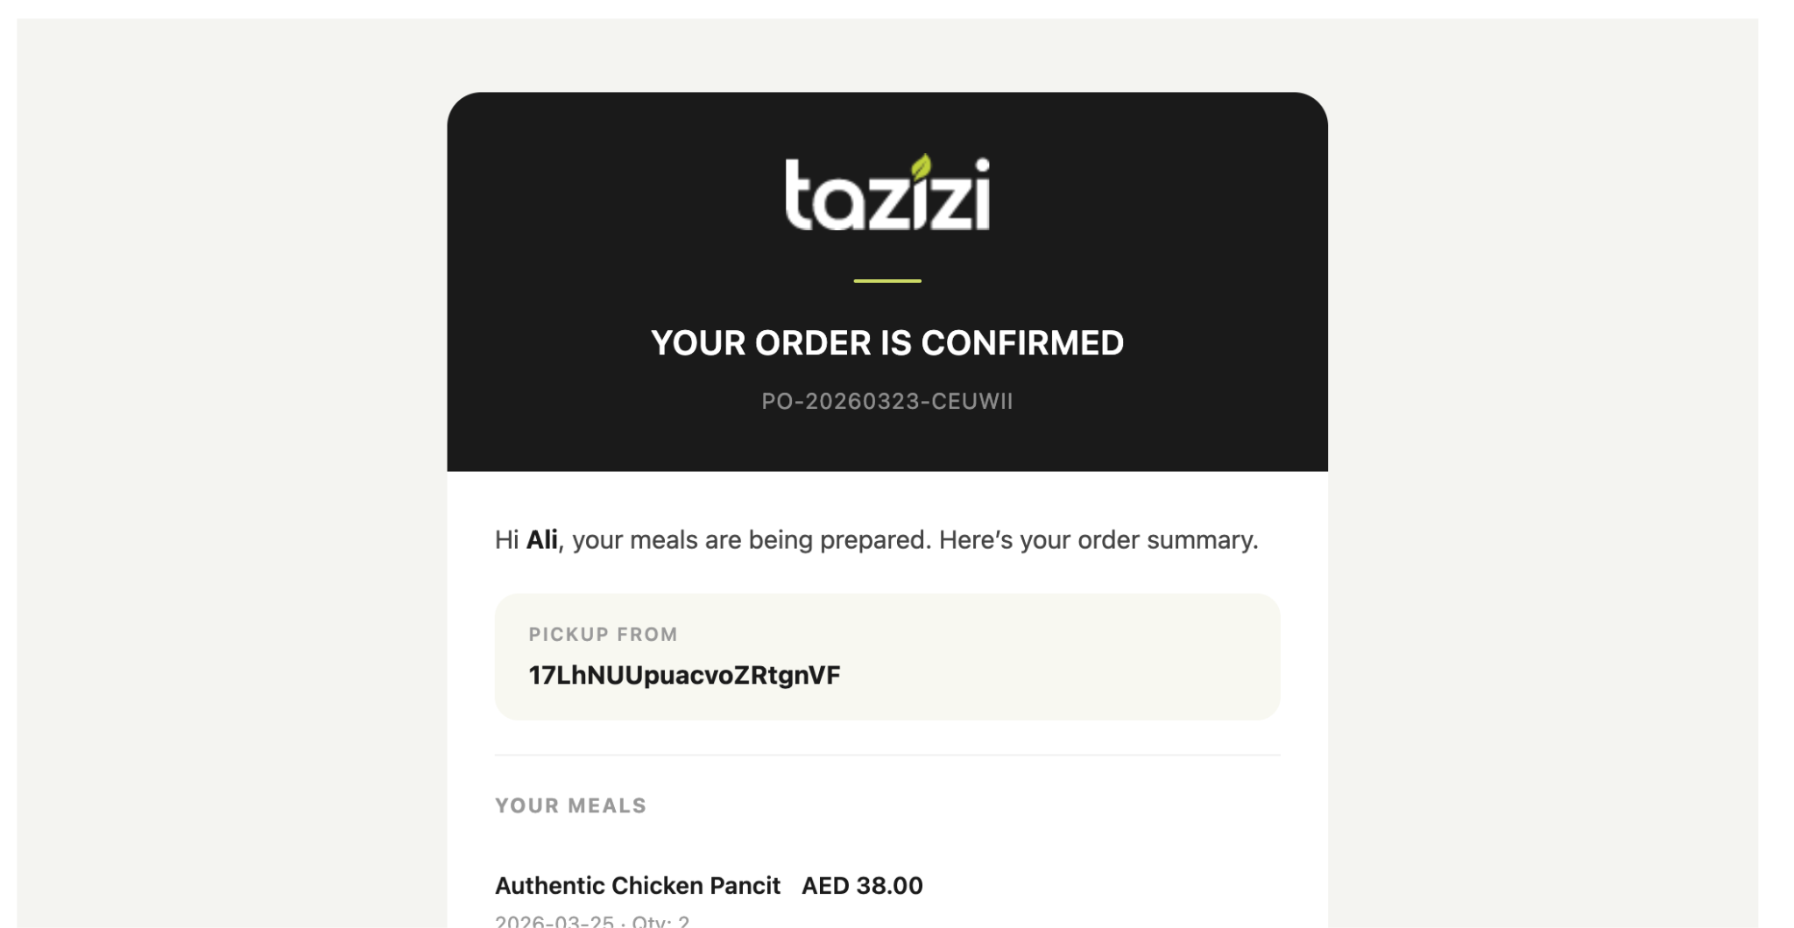

- Rather than location ID, in the whole email location used 2-3 times, make sure to have name of the location not ID.
- 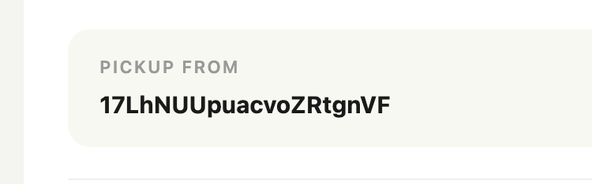
- In the email the total amount area alignment is totally out, please fix that as well as the meals and prices (see image)
- 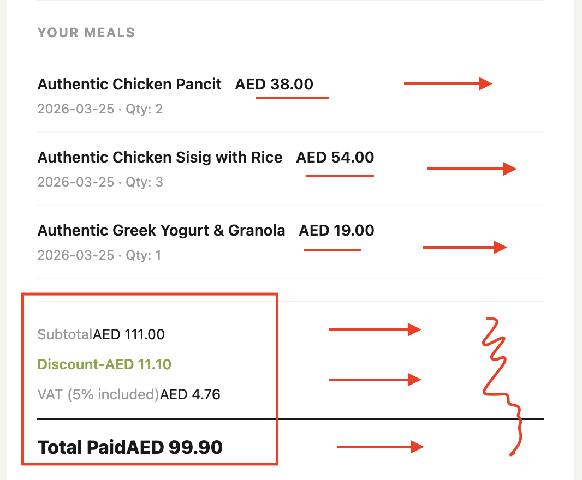

- sort by: manual sorting (later after updating the above points)

Note: shared the brand book and logo files with you

